Full Name | Nanubolu Sai Surya Kiran
Batch | MS FSD DEC 2021 Cohort 1
Project Name | File Project
Project Submission Date | 07-02-2022

Source Code
package lockedMepackage;

import java.io.*;
import java.util.*;

public class LockedMeClass
{
static final String filesPath ="D:\\Kiran\\LockedMeFiles";
static final String errorMessage="Error Occurred. Please Contact admin@Lockedme.com";
static Scanner obj = new Scanner(System.in);
public static void main(String[] args)
{
int ch;
do
{
displayMenu();
System.out.println("\n Please enter your Choice");
ch=Integer.parseInt(obj.nextLine());

switch(ch)
{
case 1:displayAllFiles();
break;
case 2:addNewFiles();
break;
case 3:deleteFiles();
break;
case 4:searchFiles();
break;
case 5:System.exit(0);
break;
default:System.out.println("Please choose valid option");
}
}
while(ch>0);
obj.close();

}
/**
* This function will display the Welcome page
*/

public static void displayMenu()
{
System.out.println("=========================================================");
System.out.println("\t \t Welcome to LockedMe.com \t");
System.out.println("=========================================================");
System.out.println("\t \t Please Choose your Option\t \n");
System.out.println("\t 1. Display All Files from the Directory.");
System.out.println("\t 2. Create new File in the Directory.");
System.out.println("\t 3. Delete a File from the Directory.");
System.out.println("\t 4. Search a File from the Directory.");
System.out.println("\t 5. Exit. \n\n");
System.out.println("\t\t Developed by");
System.out.println("\t\t Nanubolu Sai Surya Kiran.");
System.out.println("\t\tEmail: kirannanubolu@gmail.com \n\n");

}

/**
* This Method Displays all the Files in the Directory
*/

public static void displayAllFiles()
{
try
{
File folder= new File(filesPath);
File[] listOfFiles=folder.listFiles();

if(listOfFiles.length==0)
{
System.out.println("No Files Exist in the Directory");
}
else
{
System.out.println("The Below are the files Present : \n ");
for(var l: listOfFiles)
{
System.out.println(l.getName());
}
}
}
catch(Exception Ex) {
System.out.println(errorMessage);
}
}
public static void addNewFiles()
{
try
{
String fileName;
System.out.println("Please enter the file Name");
fileName = obj.nextLine();

File folder= new File(filesPath);
File[] listOfFiles=folder.listFiles();

LinkedList<String> filenames=new LinkedList<String>();

for(var l: listOfFiles)
filenames.add(l.getName());

if(filenames.contains(fileName))
{
System.out.println("File already exists. Please give another name");

}
else
{
int linescount;
System.out.println("Please enter the number of lines to be created");
linescount = Integer.parseInt(obj.nextLine());

FileWriter fw= new FileWriter(filesPath+"\\"+fileName);
for(int i=1;i<=linescount;i++)
{
System.out.println("Enter the Data to be stored in line : "+i);
fw.write(obj.nextLine()+"\n");
}
System.out.println("\t"+fileName + " File Created Successfully");
fw.close();

}
}
catch(Exception Ex)
{
System.out.println(errorMessage);
}

}

/**
* This function Deletes the file as per the user
*/
public static void deleteFiles()
{

try
{
String fileName;
System.out.println("\n Enter the file name to be deleted \n");
fileName=obj.nextLine();

File file= new File(filesPath+"\\"+fileName);
if (file.exists())
{
file.delete();
System.out.println("File is deleted successfully ");
}
else
System.out.println("File doesnot exist");
}
catch(Exception Ex)
{
System.out.println(errorMessage);
}

}

/**
* This Method will search the file and display the contents of it based on user
*/
public static void searchFiles()
{

try
{
String fileName;
System.out.println("\n Enter the file name to be searched ");
fileName=obj.nextLine();

File folder= new File(filesPath);
File[] listOfFiles=folder.listFiles();

LinkedList<String> filenames=new LinkedList<String>();

for(var l: listOfFiles)
filenames.add(l.getName());

if(filenames.contains(fileName))
{
System.out.println("\n File is found \n ");
}
else
System.out.println("\n File is not found");

}
catch(Exception Ex) {
System.out.println(errorMessage);
}

}

}

Screen Shots
Welcome Page
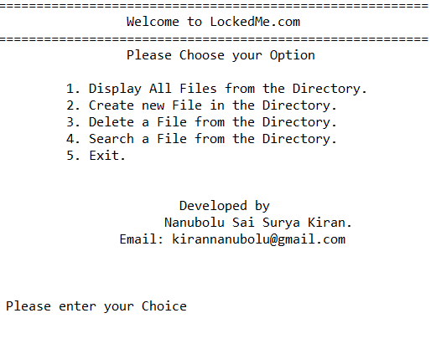
Display all Files
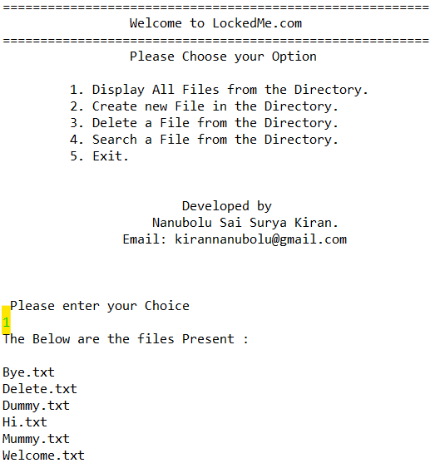
Creating a new file
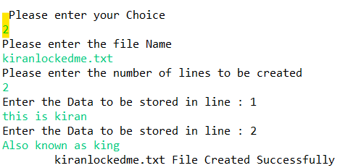
File Already exists
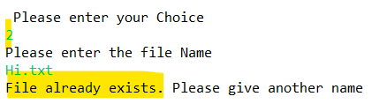
Delete file case 1 : File Does not exist
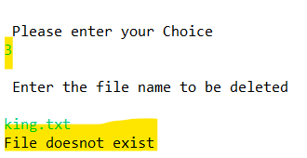
Case 2 : File is found and deleted
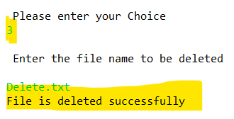
Search a file Case 1 : File is found
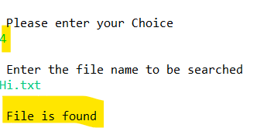
Case 2 : File not found
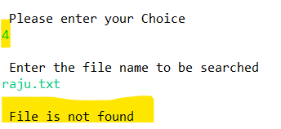
Exit
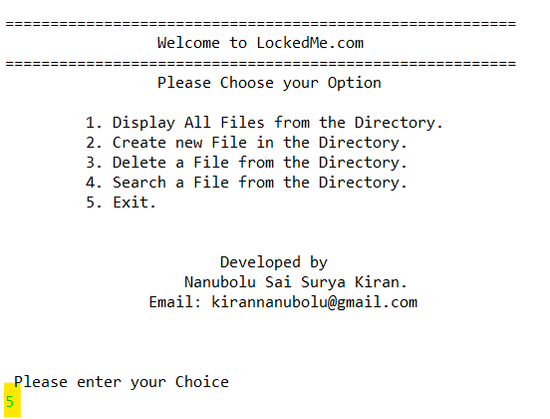

START
FILE EXISTTTT
FILE EXIST
FILE EXIST
END
MAIN MENU
1. DISPLAY ALL FILES
2. ADD A NEW FILE
3. DELETE A FILE
4. SEARCH A FILE
5. EXIT

DISPLAY ALL FILES
ADD A NEW FILE
DELETE A FILE
SEARCH A FILE
ALL FILES ARE DISPLAYED
ENTER THE FILE NAME AND LINES COUNT
ENTER THE FILE NAME TO BE DELETED
ENTER THE FILE NAME TO BE SEARCHED
FILE ALREADY EXISTS
FILE DELETED SUCCESSFULLY
FILE FOUND SUCCESSFULLY
FILE CREATED SUCCESSFULLY
FILE NOT FOUND
FILE NOT FOUND
YES
YES

